FULL REPORT AVAILABLE AT THIS LINK: GOT MANGANESE REPORT.pdf

GOT MANGANESE? DETAILED DESIGN REPORT
BEDFORD BOROUGH WATER TREATMENT PLANT IMPROVEMENTS
12-401: CEE DESIGN

Carmen Hagerty, Kate Hanson, Samantha Lee, Flannery McNair, Shria Shyam
December 11, 2024

TABLE OF CONTENTS
TABLE OF CONTENTS 2
1.0 PROBLEM DEFINITION 3
2.0 DESIGN SOLUTION 5
2.1 MAJOR COMPONENTS AND SUBCOMPONENTS 5
2.2 FUNCTIONS 5
2.3 CONSTRAINTS 6
2.4 COST ESTIMATE 6
2.5 ENVISION FRAMEWORK 6
3.0 MAJOR CHANGES 8
3.1 SOLAR-POWERED AERATORS 8
3.2 INJECTION PIPE LOCATION 8
4.0 CONSTRUCTION/FABRICATION PROCESS 9
4.1 EQUIPMENT 9
4.2 LABOR REQUIREMENTS 9
4.3 CONSTRUCTION SEQUENCE 9
4.4 PROJECT TIMELINE 9
4.5 SAFETY CONSIDERATIONS 10
4.6 FUTURE WORK 10
5.0 REFERENCES 11
APPENDIX A. ENVISION ASSESSMENT 14
APPENDIX B. ENVISION CHECKLIST 15
APPENDIX C. SPECIFICATIONS 16
SECTION 31 23 19 DEWATERING 16
SECTION 21 11 00 FIRE SPRINKLER FITTINGS AND VALVES 18
SECTION 31 20 00 EARTHWORK 29
APPENDIX D. THE CARRIER WATER SYSTEM 32
APPENDIX E. CONSTRUCTION/FABRICATION PROCESS. 34
E.1 AERATOR 34
E.1.1 EQUIPMENT 34
E.1.2 LABOR REQUIREMENTS 34
E.1.3 CONSTRUCTION SEQUENCE 34
E.2 CLEARWELL BAFFLES 34
E.2.1 EQUIPMENT 34
E.2.2 LABOR REQUIREMENTS 34
E.2.3 CONSTRUCTION SEQUENCE 35
E.3 CARRIER WATER SYSTEM 35
E.3.1 EQUIPMENT 35
E.3.2 LABOR REQUIREMENTS 35
E.3.3 CONSTRUCTION SEQUENCE 35
E.4 STORAGE BUILDING 36
E.4.1 EQUIPMENT 36
E.4.2 LABOR REQUIREMENTS 36
E.4.3 CONSTRUCTION SEQUENCE 36
APPENDIX F. AERATOR QUOTE 37
APPENDIX G. CALCULATIONS 38
APPENDIX H: PIPE NETWORK CODE 62

1.0 PROBLEM DEFINITION
The Bedford Water Treatment Plant, shown in Figure 1, provides drinking water to Bedford Borough. Unfortunately, the water treatment plant has recently struggled to cope with reduced water flows and increased manganese levels, which have compromised its ability to serve the Bedford Borough community effectively and meet water quality standards. The Got Manganese? team seeks to design upgrades for a more sustainable water treatment plant that can provide reliable and safe drinking water.
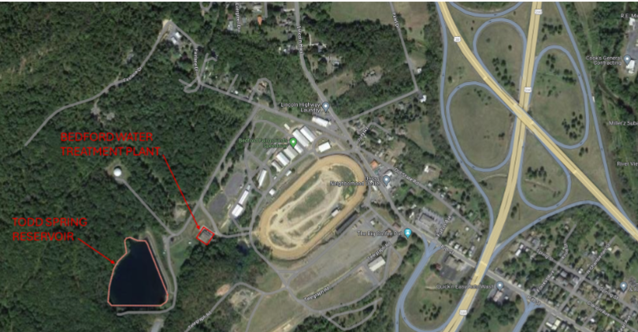
Figure 1. Todd Spring Reservoir and Bedford Water Treatment Plant (Christian and Ozis 2024).

The treatment plant must treat and supply water. The system must handle the flow rate from the intake tower while supplying enough water to meet the needs of Bedford residents. Furthermore, the drinking water produced by the upgraded plant must adhere to federal and state drinking water treatment regulations to protect public health. While achieving these key functions, the plant upgrades cannot exceed the $3 million budget and schedule and cannot interfere with surrounding infrastructure projects (e.g., dam, spillway). The time to design cannot exceed three months, and the time to construct cannot exceed the project timeline. Our design must consider the local topography (as water flows downhill), soil conditions (as soil chemistry, texture, and microbiology could influence manganese and iron mobilization), and site access conditions, while still producing effluent that meets all treatment regulations set by the Environmental Protection Agency. Specifically, based on 50 CFR Parts 141-142 and Pennsylvania Code Chapter 109 Subchapter B, the effluent concentrations cannot exceed 0.05 mg/L manganese or 0.3 mg/L iron (CFR 1975, PA Code 1971, US EPA 2015). Furthermore, each primary containment for the chemicals used in the water treatment train must be accompanied by secondary containment that adheres to the regulations laid out in 40 CFR 267.195. Lastly, the chemical storage building must adhere to the National Fire Protection Association codes.

Three possible areas for improvement in the current treatment plant have been identified, including (1) removal of metals, especially manganese; (2) disinfection; and (3) safe chemical storage. The recommended improvements to the treatment plant must correspondingly address the following three principal subfunctions: (1) produce an effluent with a manganese concentration less than 0.05 mg/L; (2) provide a means for safe disinfection; and (3) provide a safe and compliant location for chemical storage.

The objectives for this design are to (1) maximize sustainability, (2) minimize operational cost, and (3) minimize project (capital) cost. The goal is to balance sustainability with minimizing operational and project costs, which is important in Bedford Borough due to its limited financial resources.

The following project stakeholders have been identified (in order of importance/influence in the project): the Bedford Borough community, the Environmental Protection Agency (EPA) and Pennsylvania Department of Environmental Protection (DEP), and the Municipal Authority of Bedford Borough (MABB). The community is prioritized during project planning, so more powerful or financially influential stakeholders do not undermine community voices. However, several other players have an important role in influencing project directions. For example, the EPA and DEP have regulatory oversight on the project. The project’s success depends on adhering to EPA and DEP regulations, which drive and constrain the project. Furthermore, MABB controls the financial resources allocated to the project, so they play a critical role in determining the scope and feasibility of proposed upgrades.

This project impacts public health, safety, and welfare by addressing crucial aspects of drinking water quality. Decreasing contaminant levels in the water can directly mitigate the risks associated with carcinogenic and non-carcinogenic exposures, while coliform inactivation can lower the likelihood of waterborne diseases. This project can help protect residents from harmful pollutants and pathogens by promoting safer water. However, using chemicals during water treatment, particularly during disinfection, introduces the potential for creating disinfection byproducts. If these byproducts are not properly managed, they could pose long-term health risks, highlighting the need for meticulous control and oversight in the treatment process to prevent unintended health consequences (Kalita et al. 2024). As a result, the project must carefully balance the benefits of safe drinking water with effective chemical management to ensure comprehensive protection for the community.

While this project certainly impacts local public health, safety, and welfare, a drinking water treatment plant can also affect several global, cultural, social, environmental, and economic factors. Indeed, access to clean drinking water is a global issue, especially with the growing threat of emerging pollutants. Water treatment can help support the United Nations Sustainable Development Goals 6 (Clean Water and Sanitation) and 3 (Good Health and Well-Being). Moreover, involving the community in planning and decision-making can have cultural implications, such as enhanced local pride and a sense of ownership of the water treatment plant project. Furthermore, an upgraded water treatment plant can ensure that marginalized and low-income groups have equal access to clean water, promoting social equity and reducing disparities. However, the plant’s construction may alter the landscape, affecting traditional land uses and scenic values, and could potentially displace residents or businesses, leading to social upheaval. While the upgraded plant can improve access to clean water for marginalized groups and support healthier ecosystems by removing contaminants, it may also cause temporary water disruptions and environmental risks if wastes and byproducts are not managed properly. Finally, the project can promote economic growth by creating jobs and boosting local employment, but higher water bills or taxes could financially burden residents, especially those with lower incomes. Such impacts should be considered when designing upgrades to the water treatment plant.

Considering the diverse impacts of this project on interconnected global, cultural, social, environmental, and economic factors, the project team aims to ensure the project’s sustainability by certifying it through Envision criteria. Envision is a framework to guide systemic change in the planning, design, and delivery of sustainable and resilient infrastructure and support higher performance through more sustainable choices in infrastructure development. Using the Envision Pre-Assessment checklist, a pre-assessment of the project scope evaluated potential project performance in supporting quality of life, leadership, resource allocation, natural world, and climate and resilience. The project was assessed based on each Envision criteria for feasibility within the project scope, and points were assigned according to the project feasibility. This evaluation indicated that, among the aforementioned categories, the water treatment plant upgrades project focuses primarily on improving quality of life, but the project team strives to achieve the Platinum designation through high performance in all the categories, demonstrating commitment to the sustainability of this drinking water treatment plant.

2.0 DESIGN SOLUTION

2.1 MAJOR COMPONENTS AND SUBCOMPONENTS
Three areas for improvement with the current treatment outcomes have been identified. The treatment plant upgrades must address three corresponding subfunctions with three corresponding components and associated subcomponents, summarized in Table 1. Figure 1 visualizes the proposed upgrades.
Table 1. Subfunctions addressed by key components and subcomponents of the proposed upgrades.
PROBLEM | SUBFUNCTIONS | COMPONENTS | SUBCOMPONENTS
High manganese | Produce effluent with a manganese concentration < 0.05 mg/L. | (1) Aeration | Bottom-up diffusers in Todd Spring Reservoir
 |  |  | Solar-powered aerators
 |  |  | Dissolved oxygen sensors controlling aerators
Unsafe chemical storage | Provide a safe and compliant location for chemical storage. | (2) Carrier water system* | Intake pipe
 |  |  | Carrier pipe
 |  |  | Injection pipe
 |  | (3) Chemical storage | Prefabricated chemical storage building
Unsafe disinfection | Provide a means for safe disinfection. | (4) Clearwell upgrades | Sodium hypochlorite dosing
 |  |  | Baffles
* Appendix D describes the proposed carrier water system and defines its identified subcomponents.

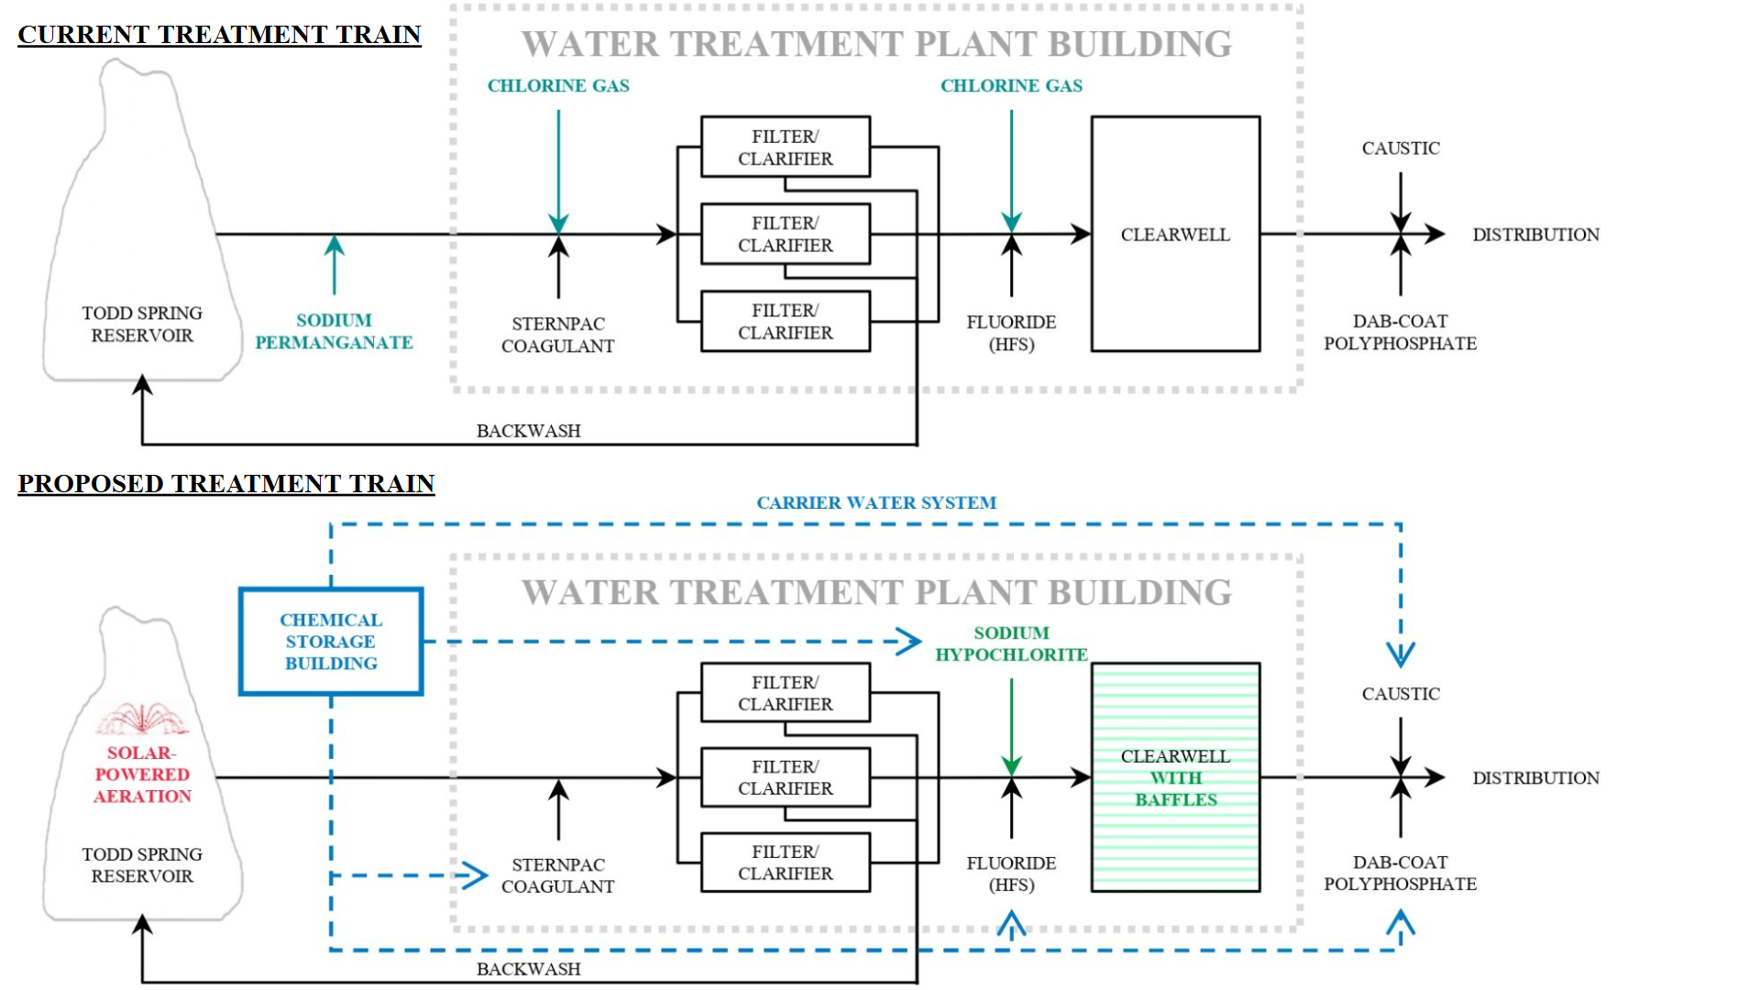
Figure 1. Changes between the current and proposed treatment systems, with key differences in color.
The items listed under “components” in Table 1 are the four aspects of the proposed upgrades requiring construction and initial investment (capital cost), as evaluated in Section 4, Section C.8, and Appendix E.

2.2 FUNCTIONS
Bottom-up aeration in Todd Spring Reservoir is implemented to help produce effluent with a manganese concentration less than the regulatory limit of 0.05 mg/L, as shown from theoretical calculations in Appendix C.6 and practical implementation by Li et al. (CFR 1975, PA Code 1971, US EPA 2015, Bedford Borough 2024, Li et al. 2019). Second, an additional chemical storage building, with a carrier water system to transport chemicals to the water treatment plant, will be constructed to meet safety requirements for chemical storage and handling. Finally, liquid sodium hypochlorite is proposed as a common option used in many treatment plants for safe disinfection (Shah and Qureshi 2008).

2.3 CONSTRAINTS
This design proposal meets project constraints as shown in Table 2.
Table 2. Reasoning for design proposal meeting all constraints.
CONSTRAINT | PROJECT MEETS CONSTRAINTS BECAUSE: | SECTION
$3 million budget | Proposed changes within budget (50-year NPV of $246K) | 2.4
Reasonable timeline | Project timeline estimated as 30 days (minimum) | 4.4
No interference with other infrastructure | Aerators placed in reservoir, away from dam and spillway
Manganese concentration below 0.05 mg/L | Aerators expected to oxidize manganese level below 0.05 mg/L | C.6
Disinfection with 3-log Giardia inactivation | 3-log inactivation with 62 mg-min/L sodium hypochlorite | C.1
Chemical storage compliant with NFPA * | Fire-rated prefabricated building includes fire suppression
Existing soil conditions | Since manganese levels are acceptable in the winter, the soil chemistry will likely be appropriate for manganese immobilization if thermal stratification is eliminated.
Existing topography | Chemical storage building is downhill from the reservoir and uphill from the plant. Gravity can guide pipe flows with minimal pumping in the current topography.
Site access | A prefabricated chemical storage building is selected to minimize the frequency of large deliveries needed to maneuver the suboptimal gravel roads leading to the site.
* NFPA refers to National Fire Protection Association regulations for fire suppression.

2.4 COST ESTIMATE
The cost estimate for the proposed design is summarized in Table 3, with full calculations presented in Appendix G. Notably, the estimated 50-year net present value of the proposed upgrades, approximately 246 thousand dollars, is considerably lower than the $3 million budget.

Table 3. Summary of proposed design cost estimate.
CAPITAL COST | Cost (one-time, at present)
Component (1): Aeration in reservoir | $34,787.42
Component (2): Carrier water system | $83,841.45
Component (3): Chemical storage building | $34,643.24
Component (4): Clearwell baffles | $2,264.21
7% tax | $10,887.54
30% contingency | $49,927.16
TOTAL CAPITAL COST | $216,351.02
OPERATIONAL COST * | Cost (annual)
Sodium hypochlorite (added to proposed system) | +$7,170.28/year
Chlorine gas (removed from existing system) | -$1,995.16/year
Sodium permanganate (removed from existing system) | -$3,045.04/year
TOTAL OPERATIONAL COST (proposed system minus existing system) | +$2,130.08
50-YEAR NET PRESENT VALUE | $245,747.71
* Operational cost is defined as the difference between the operational cost of the proposed system and the operational cost of the current system. Hence, the annual operational cost is estimated as the cost of added chemicals minus the cost of removed chemicals. Operational costs that increase from the status quo (added to the proposed system) are in red text. Operational costs that decrease from the status quo (removed from the existing system) are in green text.

2.5 ENVISION FRAMEWORK
The proposed design achieves a Platinum Envision rating under the Envision Sustainable Infrastructure Framework, earning 659 out of 923 possible points (approximately 70% of possible points), through the distribution visualized in Figure 3. An in-depth evaluation of Envision performance is presented in Appendix A, while a breakdown of points awarded is shown in Appendix B.

The Envision framework promotes sustainability, equity, and resilience in the proposed design. For example, aerators are proposed as a metal oxidation solution primarily because of their relatively high sustainability performance, especially in the Quality of Life and Natural World categories. Solar-powered aerators are proposed to decrease the impacts of high operational energy consumption during aeration on the Resource Allocation category. Table 4 summarizes how key Envision credits promoted components of the proposed design that contribute to sustainability, equity, and resilience improvements.
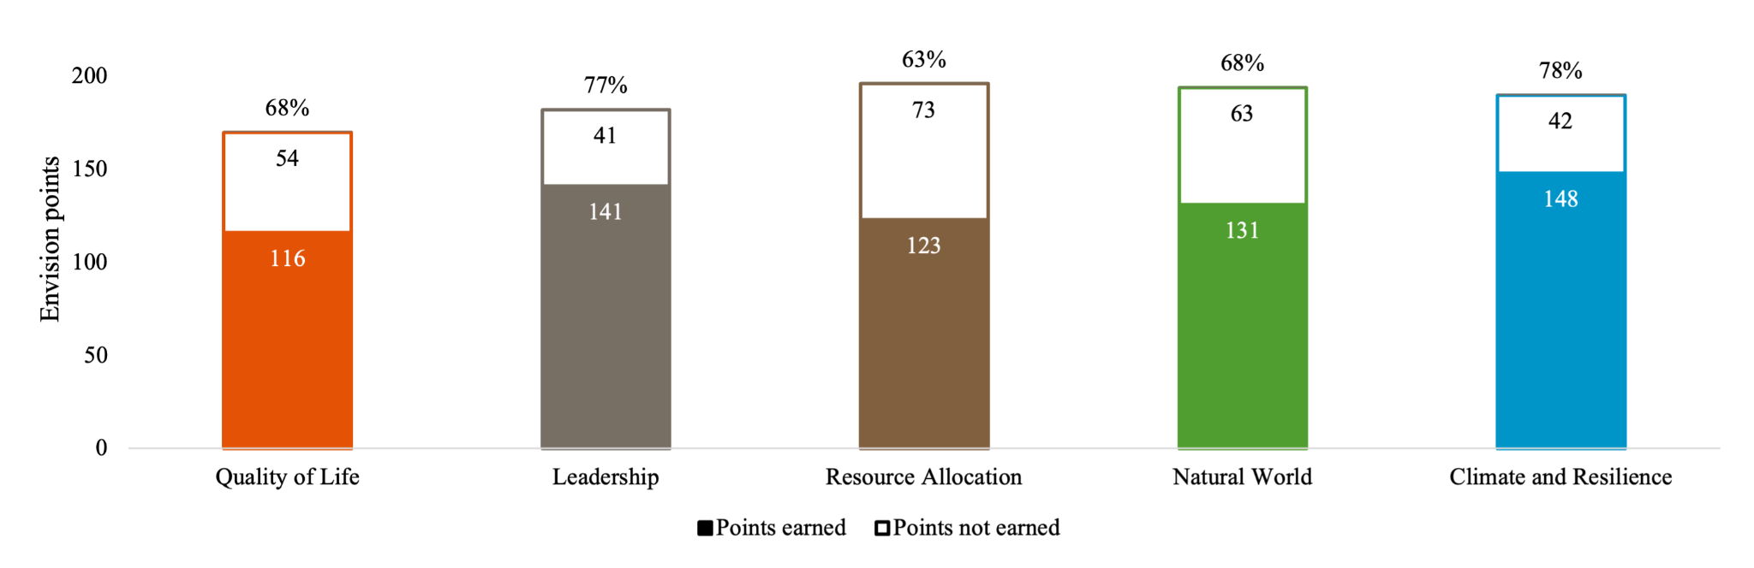
Figure 3. Envision points earned and not earned in each category for the proposed design.

Table 4. Improvements to sustainability, equity, and resilience in the proposed design based on key Envision credits.
CREDIT | COMPONENT | SUSTAINABILITY | EQUITY | RESILIENCE
QL1.1 Improve community quality of life | Lower chemical use and safer chemical storage decreases the risk of community chemical exposures, enhancing public health and safety. | ᐧ Lower chemical use and safer chemical storage helps prevent environmental spills and contamination.  ᐧ Lower chemical use decreases the demand for resource-intensive chemicals. | ᐧ Lower chemical use saves costs and avoids burdening low-income groups.  ᐧ Chemical exposure can disproportionately harm vulnerable groups.  ᐧ Lower chemical use and safer chemical storage can decrease occupational health risks to plant staff. | ᐧ Lower chemical use and safer chemical storage strengthens ecosystem resilience through decreased chemical risks.  ᐧ Lower chemical use lowers dependence on external supplies, improving resilience to supply disruptions.
QL1.2 Enhance public health and safety
LD1.3 Provide for stakeholder involvement | Community and expert feedback prioritized solutions that lower chemical use.
NW2.4 Protect surface & groundwater quality | Lower chemical use and safer storage decreases the risk of spills/leaks to surface and groundwater.
RA2.1 Reduce operational energy consumption | Real-time sensing and control decreases the aeration duration and reduces associated operational energy use. | ᐧ Real-time sensing and control prevents over-aeration that might disrupt the aquatic ecosystem.  ᐧ Lower aerator runtime improves equipment longevity. | ᐧ Lower aerator runtime lowers costs to avoid burdening low-income groups.  ᐧ Sharing sensor data with the community can build transparency. | ᐧ Real-time control adapts to changing reservoir chemistry.  ᐧ Locally connected sensors (not internet enabled) promotes resilience against cyberattacks and weather by isolating the system from external networks.
CR2.5 Maximize resilience | Real-time sensing and control ensures system responsiveness to dynamically changing reservoir chemistry.
RA2.3 Use renewable energy | The aerators are solar-powered and use renewable energy. | ᐧ Solar power provides a sustainable alternative to fossil fuels. | ᐧ Solar power eliminates aeration’s energy cost burden to low-income groups. | ᐧ Solar is resilient to power outages, giving uninterrupted access to manganese free water.
NW1.4 Preserve undeveloped land | All added components are within the extents of the existing plant. | ᐧ Building on developed land preserves pristine environments.  ᐧ Reusing current structures removes the footprint of rebuilding. | ᐧ Building within the plant extents avoids displacing low-income communities.  ᐧ Undeveloped land can provide affordable recreation. | ᐧ Natural ecosystems can buffer against climate impacts, such as floods and heatwaves.
CR2.6 Improve infrastructure integration | All added components are integrated into the existing treatment plant infrastructure.

3.0 MAJOR CHANGES

3.1 SOLAR-POWERED AERATORS
Solar panels are added to the aerators to eliminate operational energy consumption during aeration and add renewable energy to the proposed design, improving Envision performance. Using local solar power for aeration can also eliminate the need to install a new electric line from the treatment plant to the reservoir, as the aerators can draw power from the solar panels at the reservoir. While implementing solar panels increased capital costs considerably, the availability of solar power eliminated the need for daily electricity costs during aerator operation and additional excavation to install an electricity connection back to the water treatment plant, leading to a lower 50-year net present value compared to a baseline of aeration without solar panels (ProLake 2024).
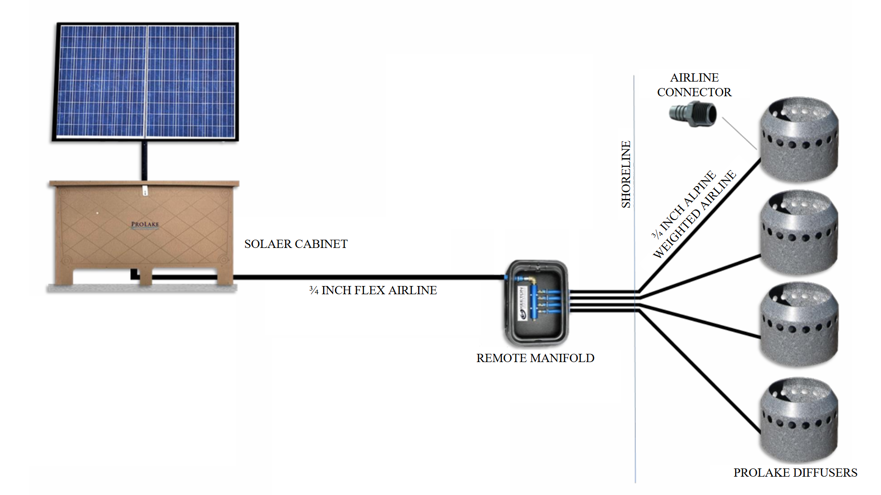
Figure 4. Schematic diagram of solar-powered aeration components and connections (ProLake 2024).

3.2 INJECTION PIPE LOCATION
While the injection pipe was initially designed to go uphill from the chemical storage building via the shortest pipe length to the potable water line, the injection pipe is repositioned to cover a downhill, albeit longer, distance to forego pumping. Figure 4 visualizes the changed orientation of the injection pipe.
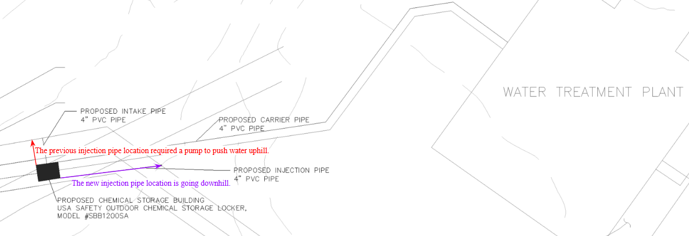
Figure 4. Change in proposed injection pipe location from preliminary (shown in red) to detailed design (shown in purple).

4.0 CONSTRUCTION/FABRICATION PROCESS
Four key components of the proposed upgrades require a detailed construction/fabrication process for their installation, namely: (1) aerators; (2) baffles in the clearwells; (3) the prefabricated chemical storage building; and (4) the carrier water system. Each component is discussed in detail in Appendix E.

4.1 EQUIPMENT
Excavators and backhoes are required for site preparation in all four construction tasks; in particular, excavators are required for digging trenches to install underground pipes for the carrier water system. Floating work platforms or boats can help workers deploy aerators in the water. Installing the cast-in-place concrete baffles will require a concrete mixer and pump to prepare and pour concrete. A forklift is required for positioning the chemical storage unit on-site. Finally, installing the carrier water system will require excavators or trenchers to dig trenches for underground pipes and a side boom or pipe layer to align, lift, and lower pipes, with support from solvent welding tools, compactors, and laser levels.

4.2 LABOR REQUIREMENTS
Skilled equipment operators are necessary to operate excavators, backhoes, concrete mixers and pumps, lifting equipment, forklifts, pipe layers, and compactors. Divers can install aerators to the reservoir bed, and electricians can install electrical connections for aerators and sensors. Carpenters, formwork installers, and steelworkers can install and dismantle formwork and set up rebar for the concrete baffles.

4.3 CONSTRUCTION SEQUENCE
The construction process includes four key tasks, as follows:
- Aerator installation. Aerator installation is not dependent on any of the other phases, occurring in a different location and with different equipment than the other tasks. However, aerator installation is coordinated with the dam team The estimated duration of aerator installation is 10 days, shown in Figure E1.
- Clearwells baffles installation. Because only one clearwell can be offline at a time, the baffle installation must finish in one clearwell before installation can begin in the other. The estimated duration of baffles installation is 15 days per clearwell, or 30 days in total, shown in Figure E2.
- Carrier water system installation. Carrier water system installation must occur before storage building installation because these activities are performed in a similar location, and the carrier water system runs under and connects to the proposed storage building. The estimated duration of storage building installation is 18 days, shown in Figure E3.
- Storage building installation. Storage building installation must occur after carrier water system installation. The estimated duration of storage building installation is 8 days, shown in Figure E4.
The construction sequence for each of these four phases are further detailed in Appendix E.

4.4 PROJECT TIMELINE
A sample timeline for the construction sequence is presented in the Gantt chart in Figure 2.
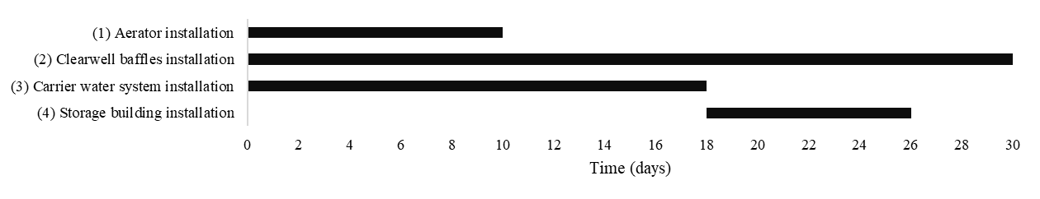
Figure 5. Gantt chart representing construction sequence for scheduling major proposed projects.
As visualized in Figure 5, the minimum duration of the project is estimated as approximately 30 days. The timeline for these tasks should be planned with consideration to other construction on-site.

4.5 SAFETY CONSIDERATIONS
All activities will adhere to OSHA regulations and integrate robust safety measures. Personal protective equipment (PPE), including hard hats, steel-toed boots, high-visibility vests, gloves, safety goggles, and hearing protection, will be mandatory on-site. For excavation tasks, trenches will be properly sloped, benched, or supported using trench boxes to comply with OSHA standards, preventing cave-ins and safeguarding workers (OSHA 2015). A comprehensive worksite analysis will include a baseline survey and periodic inspections to identify hazards and implement control measures, such as safe operating procedures, self-inspection programs, a hazard reporting system, and a thorough investigation of incidents to mitigate future risks. Regular maintenance of equipment and safety gear, such as lockout/tagout systems and machine guards, will be enforced alongside immediate access to first aid and emergency care. Training programs will equip all team members with skills to identify, prevent, and control potential hazards, while managers and supervisors will receive additional instruction to ensure effective oversight. Thus, the project will maintain a safe environment and secure worker safety.

4.6 FUTURE WORK
The construction documents will be completed by refining equipment staging zones, creating precise plans for aerator deployment, and developing cut-and-fill plans for excavation. Equipment staging zones will be strategically designated to minimize interference with active work areas and ensure efficient material and equipment flow. The aerator deployment plan will include detailed diagrams showing exact locations, anchoring methods, and electrical connections for sensors and power. Cut-and-fill calculations will balance excavation needs, optimizing soil use on-site to minimize material transport and associated costs. These additions will create an actionable set of documents for successful project execution.

Furthermore, as part of a proposed summer research project, sample aerators can be deployed in the Todd Spring Reservoir. Deployment is necessary to confirm feasibility due to the limited instances of prior implementation. The project will begin with a pilot-scale deployment, testing one or two aerators to assess factors such as oxygen diffusion efficiency, power consumption, and durability under operational conditions. Aerator placement will be guided by computational fluid dynamics (CFD) models to ensure even oxygen distribution and effective mixing across the reservoir. Field measurements will validate the CFD results and inform adjustments to the deployment strategy. The research will also evaluate the integration of sensors for real-time monitoring and control, enabling adaptive management of aeration to respond to changing reservoir conditions. Insights from this project will be used to refine the full-scale deployment plan and establish best practices for operation and maintenance.

5.0 REFERENCES
Adafruit. 2024. “Flanged Weatherproof Enclosure With PG-7 Cable Glands.” Adafruit. Accessed November 4, 2024. https://www.adafruit.com/product/3931.
Amazon. 2024. “Arduino Uno Rev3 [A000066].” Amazon. Accessed November 6, 2024. https://www.amazon.com/Arduino-A000066-ARDUINO-UNO-R3/.
Autodesk. 2024. “A Guide to Excavation Costs.” Autodesk. Accessed November 8, 2024.
Bagastyo, A. Y., E. Nurhayati, S. P. H. Manah, A. A. W. R. Iswari, A. Yulikasari, I. D. A. A. Warmadewanthi, and T.-F. Lin. 2023. “The role of aeration and pre-chlorination prior to coagulation-flocculation process in water treatment: A laboratory and field research in Indonesia.” Case Studies in Chemical and Environmental Engineering, 7. https://doi.org/10.1016/j.cscee.2023.100352.
Bedford Borough. 2024. “MABB - Water Discoloration - Bedford Borough.” Bedford Borough. Accessed September 8, 2024. https://www.bedboro.com/notices/mabb-water-discoloration/.
Brezonik, P and Arnold, W. 2011. Water Chemistry: An Introduction to the Chemistry of Natural and Engineered Aquatic Systems. Oxford, UK: Oxford University Press.
CFR (Code of Federal Regulations). 1975. National Primary Drinking Water Regulations. CFR 141-143. Washington, D.C.: CFR.
ChemWorld. 2024. “12.5% Sodium Hypochlorite - 55 Gallons.” ChemWorld. Accessed November 3, 2024. https://www.chemworld.com/Sodium-HypoChlorite-p/cw56-55.htm.
Concrete Network. 2023. “Concrete Price Considerations - Cost of Concrete.” Concrete Network. Accessed November 6, 2024. https://www.concretenetwork.com/concrete-prices.html.
CVSD (Castro Valley Sanitary District Code). 2024. Construction Details. Castro Valley, CA: CVSD.
Drainage Solutions, Inc. 2024. “NDS 12” Round Grate - Gray (Each) 1260.” Drainage Solutions, Inc. Accessed November 6, 2024. https://thedrainagesource.com/nds-12-round-grate-gray-each/.
EPA. 2003. “EPA Guidance Manuals: CT Tables.” EPA CT Tables. Accessed November 3, 2024. https://www.dbstephens.com/wp-content/uploads/2018/08/EPA-CT-Tables.pdf.
Evans, J. 2002. “SternPAC Specifications.” SternPAC. Accessed November 4, 2024. https://ehslegacy.unr.edu/msdsfiles/32489.pdf.
Gelera, G. 2021. “Bedford County, PA: Electric Rates From 60 Providers.” Find Energy. Accessed October 7, 2024. https://findenergy.com/pa/bedford-county-electricity/.
Gilson. 2024. “MINIPULS 3 Peristaltic Pumps.” Gilson. Accessed November 4, 2024. https://www.gilson.com/default/shop-products/minipuls-3-peristaltic-pumps.html.
Grainger. 2024. “General Catalog.” Grainger. Accessed November 6, 2024. https://www.grainger.com/content/general-catalog.
Hanna Instruments. 2024. “Galvanic Dissolved Oxygen Probe for HI9147.” Hanna Instruments. Accessed November 4, 2024. https://www.hannainst.com/galvanic-dissolved-oxygen-probe-hi76409.html.
Home Depot. 2024. “2-Wire Submersible Wiring Kit.” Home Depot. Accessed November 4, 2024. https://www.homedepot.com/pep/Everbilt-2-Wire-Submersible-Wiring-Kit-EBSWK-2/205617989.
ICC (International Code Council). 2015. International Plumbing Code. ICC 305.4. Washington, D.C.: ICC.
Kalita, I. Kamilaris, A. Havinga, P. Reva, I. 2024. “Assessing the Health Impact of Disinfection Byproducts in Drinking Water.” American Chemical Society, 4(4): 1564-1578. https://pmc.ncbi.nlm.nih.gov/articles/PMC11019713/.
Li, N. Huang, T. Mao X. Zhang, H. Li, K. Wen, G. Lv X. Deng, L. 2019. “Controlling reduced iron and manganese in a drinking water reservoir by hypolimnetic aeration and artificial destratification.” Science of The Total Environment, 685: 497–507. https://doi.org/10.1016/j.scitotenv.2019.05.445.
Moore, R. 2023. “Which discount rate should I use?” Scioto Analysis. Accessed November 6, 2024. https://www.sciotoanalysis.com/news/2023/1/24/which-discount-rate-should-i-use.
Murphy, S. 2007. “General Information on Alkalinity.” City of Boulder. Accessed November 3, 2024. https://bcn.boulder.co.us/basin/data/NEW/info/Alk.html.
Koenders Water Solutions. 2019. “Bottom Up Aeration VS Surface Aeration.” Koenders Water Solutions Inc. Accessed November 6, 2024. https://www.koenderswatersolutions.com/blog/the-importance-of-bottom-up-aeration-vs-surface-aeration.html.
OSHA. 2015. “Trenching and Excavation Safety.” US Department of Labor. Accessed December 8, 2024. https://www.osha.gov/sites/default/files/publications/osha2226.pdf.
Pennsylvania Code & Bulletin (PA Code). 1971. Safe Drinking Water. Pennsylvania Code Chapter 109 Subchapter B. Harrisburg, PA: PA Code.
Pennsylvania Department of Environmental Protection (PA DEP). 2015. “Demonstration of 4-Log Treatment of Viruses for Groundwater Sources.” PA DEP. Accessed November 4, 2024. https://greenport.pa.gov/elibrary/GetFolder?FolderID=3219.
Pennsylvania Department of Environmental Protection (PA DEP). 2018. “Filter Plant Performance Evaluation: Bedford Borough Water Authority.” PA DEP. Accessed November 4, 2024. https://www.dep.pa.gov/Citizens/My-Water/PrivateWells/Waterborne-Diseases/Waterborne-Diseases-PA/Pages/Filter-Plant-Performance-Evaluation.aspx.
ProLake. 2024. “Solar Pond Aeration for Ponds & Lakes Up To 2 Acres.” ProLake. Accessed December 11, 2024. https://prolake.com/solar-aeration/solaer-1-2-solar-lake-bed-aeration-for-ponds-lakes-up-to-2-acres/.
Roman, G. 1993. “Bedford Borough Water Authority As-Built.” Google Drive. Accessed November 6, 2024. https://drive.google.com/file/d/16FDl7SUeDxSA_Ot6OsYf63QzOzPF8sFW/view?usp=sharing.
Roth, C. 2024. “Safety Data Sheet: DABCO.” Carl Roth. Accessed November 3, 2024. https://www.carlroth.com/medias/SDB-0718-MT-EN.pdf.
Ramaswami, A. Milford, J. Small, M. 2005. Integrated Environmental Modeling: Pollutant Transport, Fate, and Risk in the Environment. Hoboken, NJ: Wiley.
Shah, J., and N. Qureshi. 2008. “Chlorine Gas vs. Sodium Hypochlorite: What’s the Best Option?” Opflow, 34 (7): 24–27.
Stratford Landscape Supply. 2024. “#57 Gravel - By the Cubic Yard.” Stratford Landscape Supply. Accessed December 8, 2024. https://www.stratfordlandscapesupply.com/bulkmaterials/gravel.
Superior Gas Chlorinators. 2017. “Chemical Injection Technologies.” Chlorinators. Accessed November 6, 2024. https://chlorinators.com/wp-content/uploads/2017/01/Bulletin3001CostComparisonCl2GasvsHypo2cRev1-10042010.pdf.
ULINE. 2024. “2 Drum Spill Containment Pallet with Drain.” ULINE. Accessed November 6, 2024. https://www.uline.com/Product/Detail/H-4033/Spill-Containment/2-Drum-Spill-Containment-Pallet-with-Drain.
United States Plastic Corp. 2024. “4” PVC Wafer Check Valve with EPDM Seals & SS Spring.” USP. Accessed November 6, 2024. https://www.usplastic.com/catalog/item.aspx?itemid=97990&clickid=related-slider.
USA Safety. 2024. “55-Gallon Drum x 12 - Hazmat/Chemical/Flammable Liquids - Non-Combustible - Outdoor Chemical Storage Locker.” USA Safety. Accessed November 6, 2024. https://www.usasafety.com/55-gallon-drum-x-12-hazmat-chemical-flammable-liquids-non-combustible-outdoor-chemical-storage-locker.html.
US EPA. 2015. “Drinking Water Regulations and Contaminants.” US EPA. Accessed September 9, 2024. https://www.epa.gov/sdwa/drinking-water-regulations-and-contaminants.
Valworx. 2024. “4” Electric Actuated PVC Butterfly Valve 24-240V.” Valworx. Accessed November 6, 2024. https://www.valworx.com/product/pvc-butterfly-valve-4-24-240v.
Vevor. 2024. “VEVOR Aerator, 550W Power 5.2CFM for Up to 3 Acre 50’ Includes 3/4 HP Compressor & Timer & Valves, Air Compressor for Deep Water Oxygen Circulation, for Pond, Lake, No Diffuser, Black.” Vevor. Accessed November 4, 2024. https://www.vevor.com/pond-lake-aeration-system-c_10259/vevor-pond-aerator-lake-pond-aeration-kit-3-4-hp-550w-5-2cfm-for-up-to-3-acre-p_010688443893
Wintersun Chemical. 2024. “Sodium Permanganate [NaMnO4] [CA_10101-50-5] 40% Purple Red Liquid (2850 Lb Tote).” Wintersun Chemical. Accessed October 7, 2024. https://www.wintersunchemical.com/products/sodium-permanganate-40-nsf-certified-tote.
World Population Review. 2024. “Frost lines by state.” World Population Review. Accessed November 8, 2024. https://worldpopulationreview.com/state-rankings/frost-lines-by-state.
Young, D. Munson, B. Okiishi, T. Huebsch, W. 2015. A Brief Introduction to Fluid Mechanics, 5th Ed., Wiley, New York.

